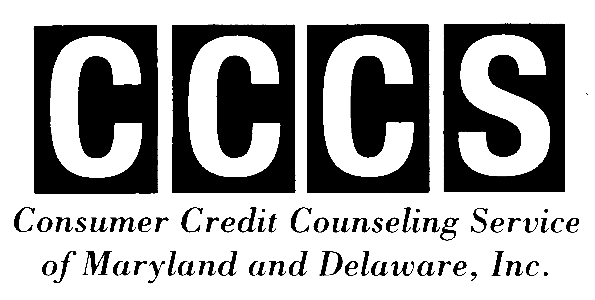
FOR IMMEDIATE RELEASE Contact Information:
November 30, 2010 NANCY STARK
410.357.0614 (phone)
410.357.0613 (fax) nstark@mind2medias.com
Helping people help themselves through Education, Financial Counseling and Debt Repayment
HOW TO SHOP FOR THE HOLIDAYS WITHOUT GOING INTO THE RED
(BALTIMORE, MD) While some consumers may spend more this holiday season than they did last year, many still plan to limit their purchases. Twenty-seven percent of the Americans who responded to Gallup’s annual poll last month said they plan to spend less on holiday gifts than they did last year. When they shop, consumers also are leaving their credit cards at home. Seventy percent of the participants in a recent National Foundation of Credit Counseling (NFCC) online poll said they plan to pay for holiday expenses with cash or debit cards this year.
“Consumers may rely on cash and debit cards for a number of reasons,” notes Deanna Booker, Community Outreach Manager for Consumer Credit Counseling Service of MD & DE (CCCS). “Some are just more aware now that they’ve redefined their financial priorities. They understand how easy it is to pile on debt and how hard it is to get out from under it once you owe too much. Other consumers may have less access to credit this year, because they already are in financial trouble. Either way, it makes sense to avoid the temptation to overspend.”
Paying with cash or using a debit card is a smart way to limit holiday purchases; however, consumers who choose this option may give up certain protections that they would receive if they used a credit card instead. The Fair Credit Billing Act allows you to contest a credit card charge for products that are poor-quality or damaged provided they cost more than $50 dollars and were purchased within 100 miles of your home. (Few issuers enforce the $50 or 100-mile rule on purchases and many offer additional purchase protection, so you may still be able to dispute a charge on shoddy merchandise purchased outside your home state, over the Internet, by mail order or phone order.)
Some debit cards also provide consumer purchase protection. If you use a debit card, the money is almost immediately drawn from your bank account. Consequently, you have less leverage, because the merchant may receive payment before you realize something is wrong with the purchase.
Whether you use credit cards, a debit card, or cash, it’s easy to overspend during the holidays. Consumers are constantly bombarded by advertising this time of year and feel pressured to meet their families’ or friends’ expectations. There are so many ways to spend -- on gifts, entertainment, decorations, travel, and shipping. Consumers often don’t realize how much they’ve spent until they’ve gone too far.
“It’s important to have a holiday budget in place even if you plan to use a debit card or cash for purchases,” Booker notes. “Otherwise, you could end up without money for essentials -- like food or rent-- at the end of the month. Start by taking a look at your financial situation. Given your current income and expenses, how much can you realistically afford to spend this season? Using that amount, decide how much to spend on each item. Then stick to your game plan. Follow your list, and shop with purpose.”
Whether you shop at the mall, online, or by phone or mail, here are some ways to shop smart and stay on budget:
- Comparison shop. A “sale” price isn’t always the “best” price. Some stores offer discounts on merchandise for a limited time; others offer discounted prices every day.
- Ask about price-matching policies and sale adjustments. Merchants may be willing to match, or even beat, a competitor’s price to make a sale. If you buy an item at a regular price, and it goes on sale the next week, you may be able to get a credit or refund for the discounted amount.
- Use coupons. Coupons can be useful if they save you money on what you already plan to buy. Some retailers may even accept coupons from their competitors. But there may be restrictions. Check for expiration dates. Avoid using one if it requires you spend more than you’ve budgeted.
- Think before buying bargain items. For example, “Buy One, Get One Free” sales may not be a bargain if you don’t really need or want the second item.
- Shop online: Take a look at websites that compare prices. If you decide to buy from an online merchant, make sure the site you’re purchasing from is reputable and secure. Secure sites normally feature an https: in the URL address and/or a padlock logo. Also consider shipping costs and delivery time before making a purchase.
- Save your receipts. You may need them later for returns or exchanges.
- Keep a spending record. List of all your purchases. This will help you stick to your holiday budget. If possible, also include important details such as order numbers, shipping costs and dates, warranties, and any return or refund policies that apply.
- Avoid last-minute shopping. In a rush, you’ll be more likely to forget your list or make “impulse buys” due to pressure.
- Ship early. If you plan to send gifts to loved ones who live out-of-town, factor in the extra time needed for shipping. Waiting until the last minute can lead to costly express or overnight costs.
- Review your success. Once the holidays are over, evaluate this year’s holiday spending strategy. Did you stick to your budget? If you didn’t, what caused you to spend more than you expected? What strategies worked well? How can you improve next year?
If you end up overspending despite your good intentions, don’t dwell on your failure. Instead, look for ways to cut back on expenses or try to bring in extra income to help you balance your budget and pay off any outstanding debts. If you aren’t sure how to deal with your current financial situation, don’t be afraid to ask for outside help.
“Nonprofit agencies like CCCS of MD & DE provide free budget and credit counseling,” Booker said. “Our certified counselors can help you assess where you stand financially and offer ideas for getting back on track. If you have serious financial problems, they may even be able to enroll you in a debt management plan to help you pay off your debts. The key is to get help as soon as possible. Don’t wait -- that’s a great gift to give yourself any time of year.”
####
Consumer Credit Counseling Service of MD & DE, Inc. (CCCS) is an accredited nonprofit agency that has served the local community since 1966. We promote economic self-sufficiency and provide help to individuals, families and communities through financial literacy education and credit and housing counseling. For further information about our vision, values, and services, please visit our website at cccs-inc.org. MD State License #14-01/ DE State License #07-01.

